How The Tiny House of Happiness Came Into Being
by Danny Torrance

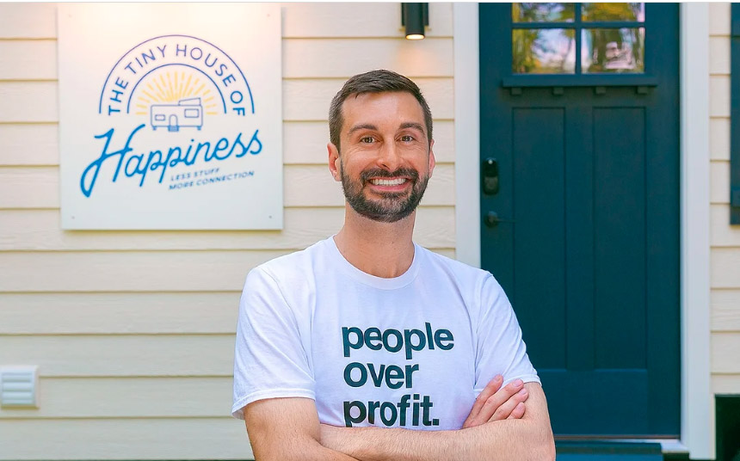
Tiny houses, positive psychology, and hoarding intervention might seem like three distinct unrelated things, but they all played a meaningful role in shaping the idea behind a new self-guided well-being retreat in Philadelphia called The Tiny House of Happiness. The concept for The Tiny House of Happiness unfolded over a number of years as founder Danny Torrance reflected on his past experience in each of these areas and noticed a thread that would weave them all together.

In 2014, Danny studied at the University of Pennsylvania’s Master of Applied Positive Psychology program to learn about the traits, conditions, and habits that promote human flourishing. He had always been interested in exploring the question “what is the good life?” and was eager to see what modern psychological science could lend to this question. He was surprised to find that research suggests we’re not very good at predicting what will make us happy in the future. Despite what we might think, it turns out that material pursuits like larger houses, nicer cars, more money, and bigger and better things don’t make us lastingly happier. Instead, having strong positive relationships with other people and connecting to something larger than ourselves are much better predictors of happiness than our stuff. This research planted the seed that he wanted to share these findings with others and help dispel the myth that happiness is on the other side of one more purchase.

A few years later, Danny had an opportunity to receive training in effective hoarding intervention and began helping individuals with hoarding behaviors sort and discard their possessions to make their homes healthier and safer. He found this work to be interesting and meaningful and it prompted him to think more deeply about the ways our possessions can either help or hinder our well-being. He noticed people that have hoarding behaviors keep things for the same reasons we all hold on to possessions: they’re useful, they have sentimental value, and we simply like them. They can evoke positive emotions, help us feel connected to our loved ones, and help us complete our activities of daily living. The problem is, however, that our attachment to things can become so strong that it leads to a large accumulation of stuff, which can ultimately get in the way of our health and well-being instead of promote it. In a sense, you really can have too much of a good thing. Sometimes, our stuff prevents us from living the life we ultimately want to live.

Around the same time, Danny took a trip to Portland, Oregon and booked a stay in something new that piqued his interest: a tiny house. He had heard about the tiny house movement and the community of people who were downsizing their lives to have more freedom, flexibility, and time to pursue the things that mattered most to them, but he hadn’t had much exposure to them outside of what he saw online. It seemed that this movement was putting the research of well-being into practice and was helping people discover a counter-cultural lifestyle that allowed them to have the time and space to reconnect to their values and live with more intentionality. Staying in a tiny house gave Danny a taste of this new lifestyle, and he was eager to learn more about tiny houses and start living a more sustainable and minimalist lifestyle at his home in Philadelphia.

The science of positive psychology, hoarding disorder, and the tiny house movement are distinct in many respects, yet they all contribute an important perspective on the way our relationship with our stuff impacts our well-being. As he was reflecting on this, Danny realized that one of the best opportunities he had to help people live more meaningful and fulfilling lives was to draw on each of these experiences to help others create a healthy, thoughtful relationship to their stuff. There is no better way to do this than to provide folks with the opportunity to stay in a tiny house to experience the benefits of living with less while practicing the habits of happiness from positive psychology. That’s what The Tiny House of Happiness offers its guests and how the idea for The Tiny House of Happiness was formed.

